**1.INTRODUCTION**

The Internet has simplified how we access weather information. Before that, you had to rely on the newspaper, TV, or phone to get weatherinformation. With the rise of the Internet came dedicated websites that provide you with the information you require in real-time at all time.

Nowadays, apps are available that run on your smartphone or tablet at all times to provide you with weather information.If you are using a desktop PC, you may like to run a weather program on it as well to look up information whenever the need arises without having to load a website first to do so.

**1.1 overview**

Having an up to date information about the weather helps us to take well-read decisions. These weather apps constantly update the forecasts for a day or hour or sometimes for even a minute. These can be simply termed as the compact weather devices, as they do not only tell about the temperature of that specific region instead they can describe the accurate time of the sunrise and sunset, the time of the rainfall, humidity levels, etc.

**1.2 purpose**

The Desktop Weather is an application that is developed for your desktop to help you easily keep track of the weather.You can select which country and city you are from and it will show you that day’s temperature and weather forecast.

**1.3 Requirements**

1.A free version needs to be available.

2.It needs to be compatible with all recent 32-bit and 64-bit versions of Windows.

3.The program needs to be a dedicated weather app and not part of a collection of tools, e.g. Rainmeter.

**Flowchart**

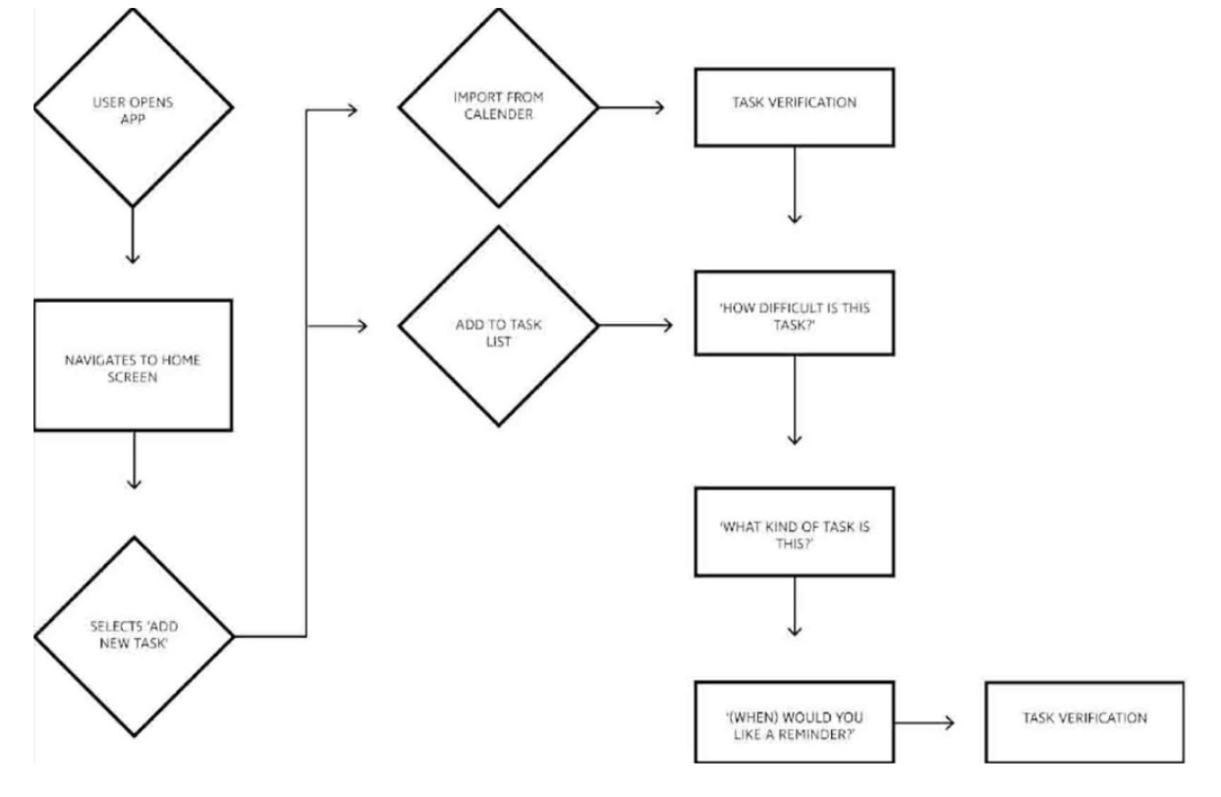

**RESULT**

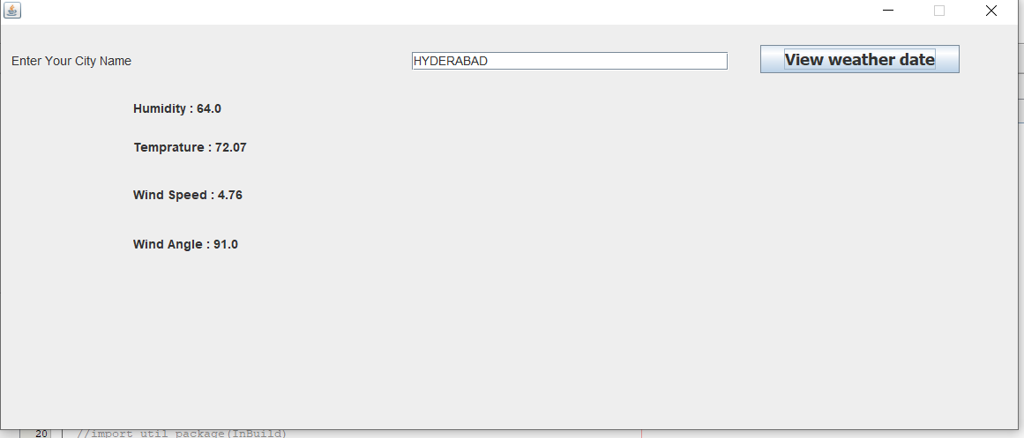

**ADVANTAGES**

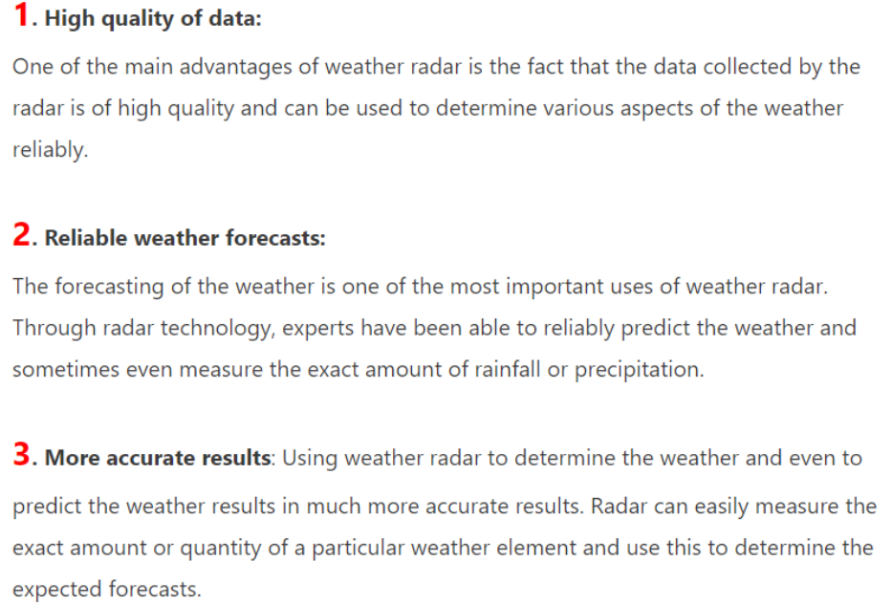

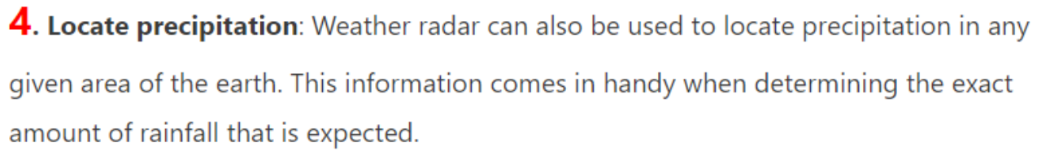

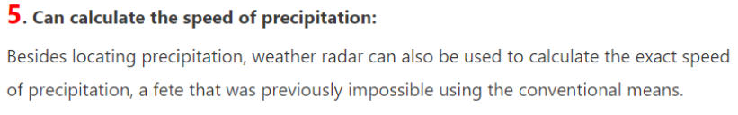

**DISADVANTAGES**

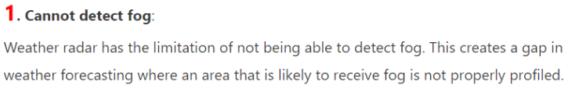

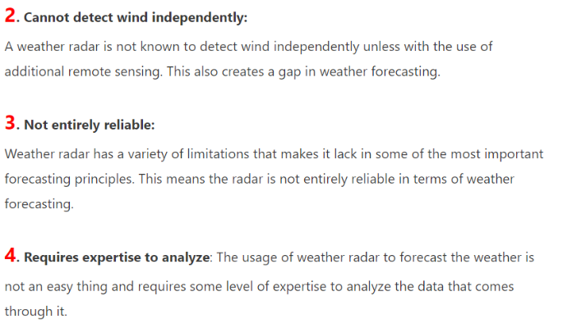

**CONCLUSION**

The Design and Developement of this Application will Significantly enhance the nature of farming and agriculture.This application is Economically,Technically and Operationally Feasible.

It is User Friendly,so that every user can handle it with ease.This application is developed such that it will not use much of RAM and memory space.

**FUTURE ENHANCEMENT**

In the next version we will be launching this application in regional languages also such as Hindi Marathi Gujarati and Tamil ect.. Also if possible we would try to make this application more user-friendly so that more and more people will be able to make good use of it.

**APPENDIX**

7.1 Source code

